CICD Project

1.create repository

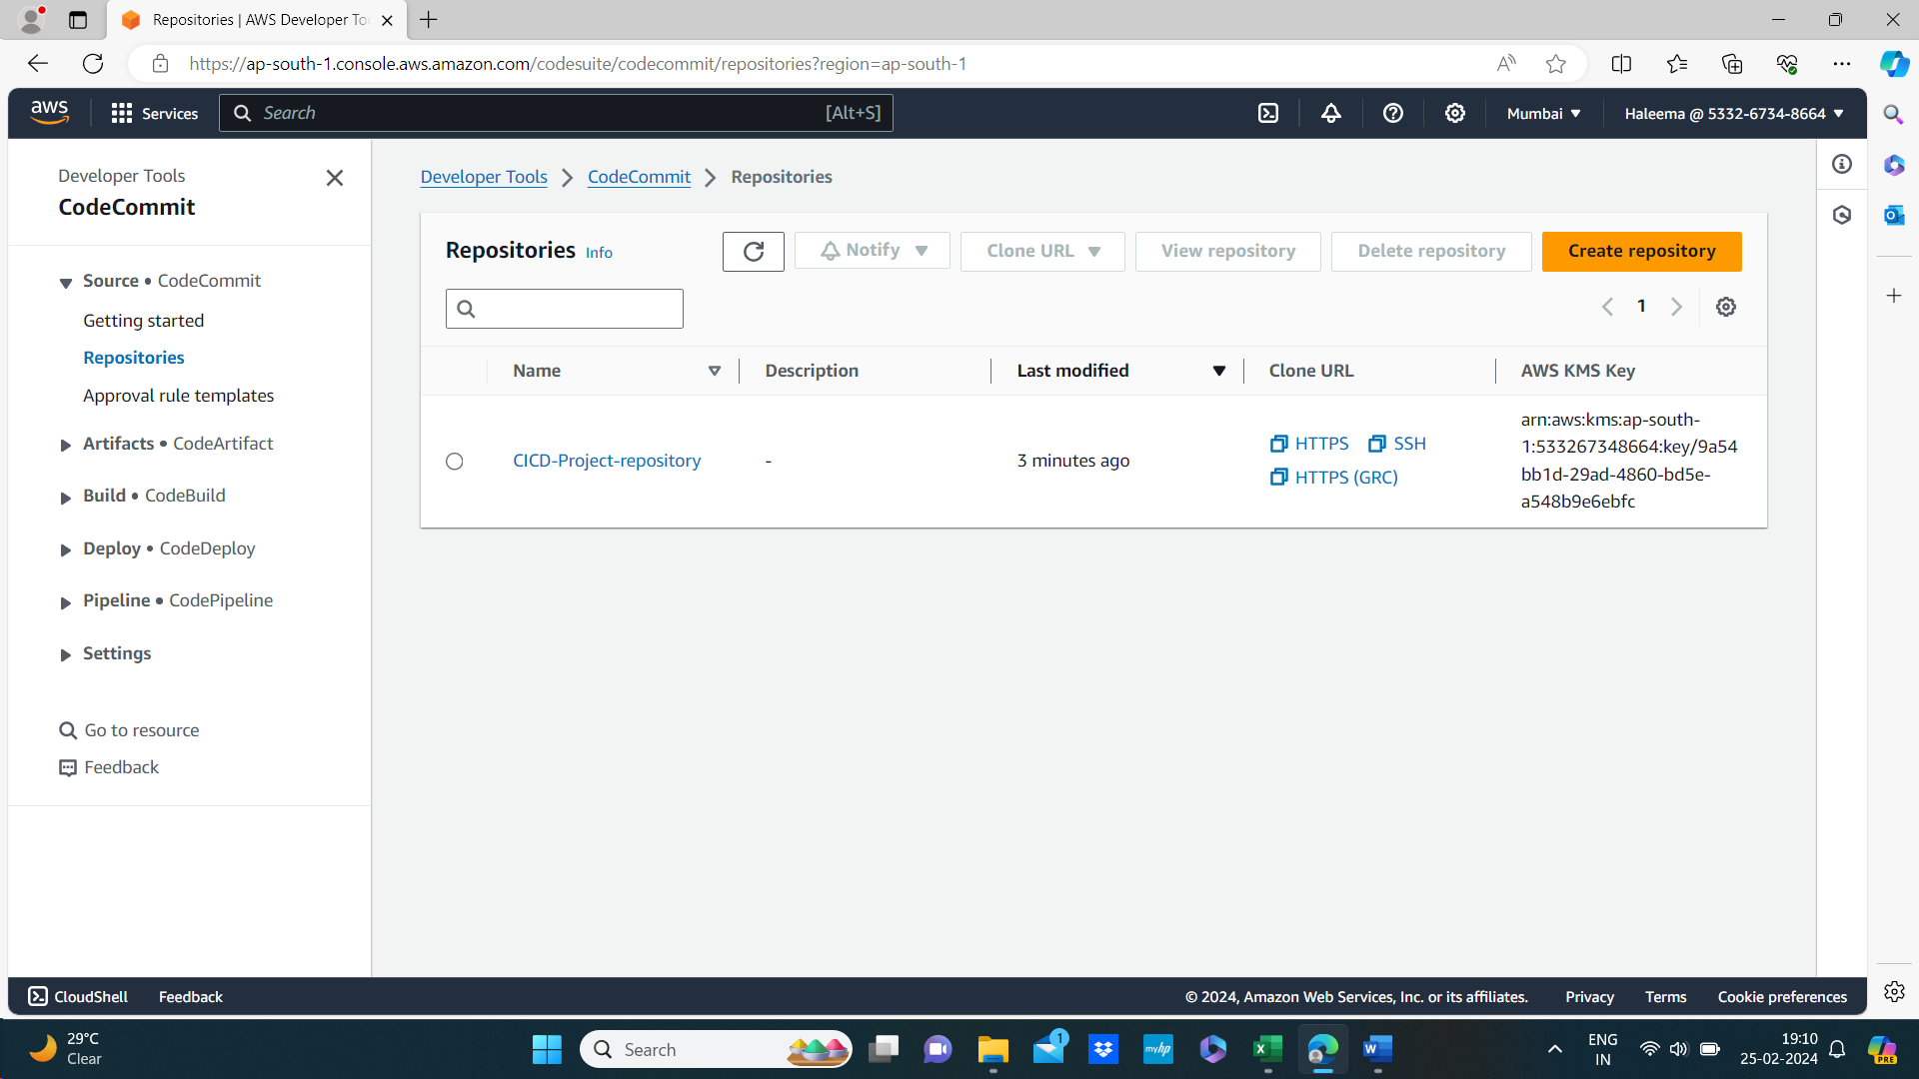

2.create ec2 instance and install git with the help of sudo yum install git command

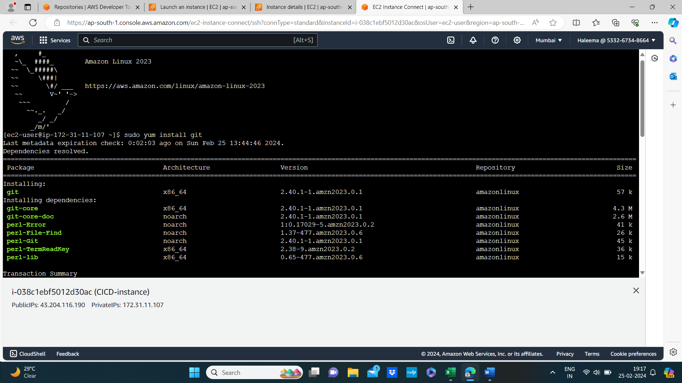

3.connect to codecommit : copy the url🡪git clone <https://git-codecommit.ap-south-1.amazonaws.com/v1/repos/CICD-Project-repository> and past it in ec2 instance make sure that git is installed in it.

Then provide username and password

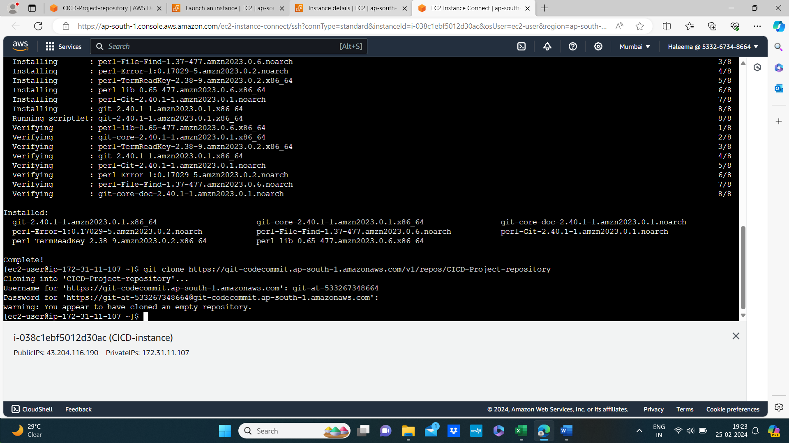

Then create a repository

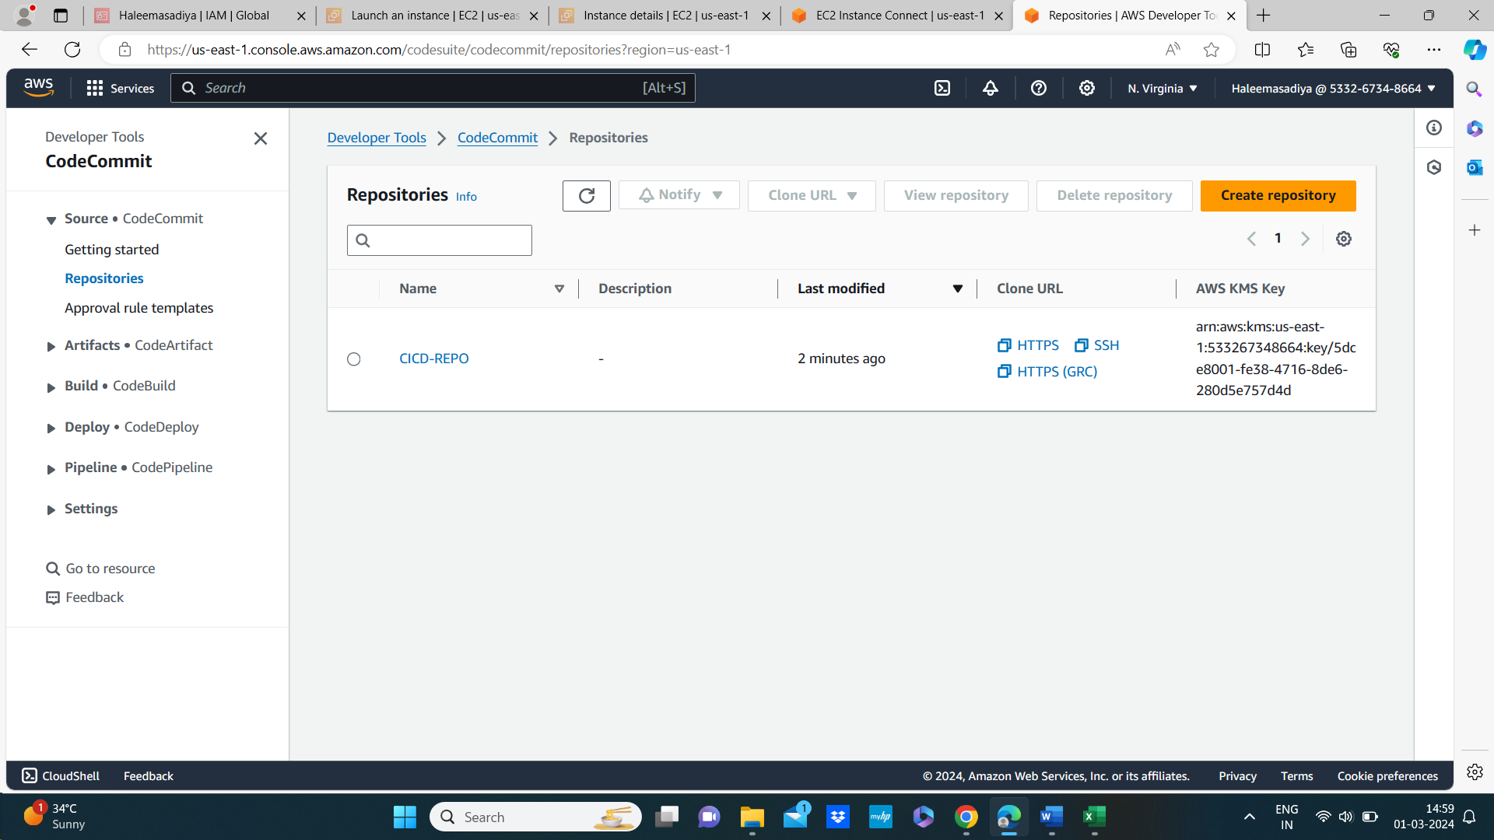

Create files and push it in the repository by using commands

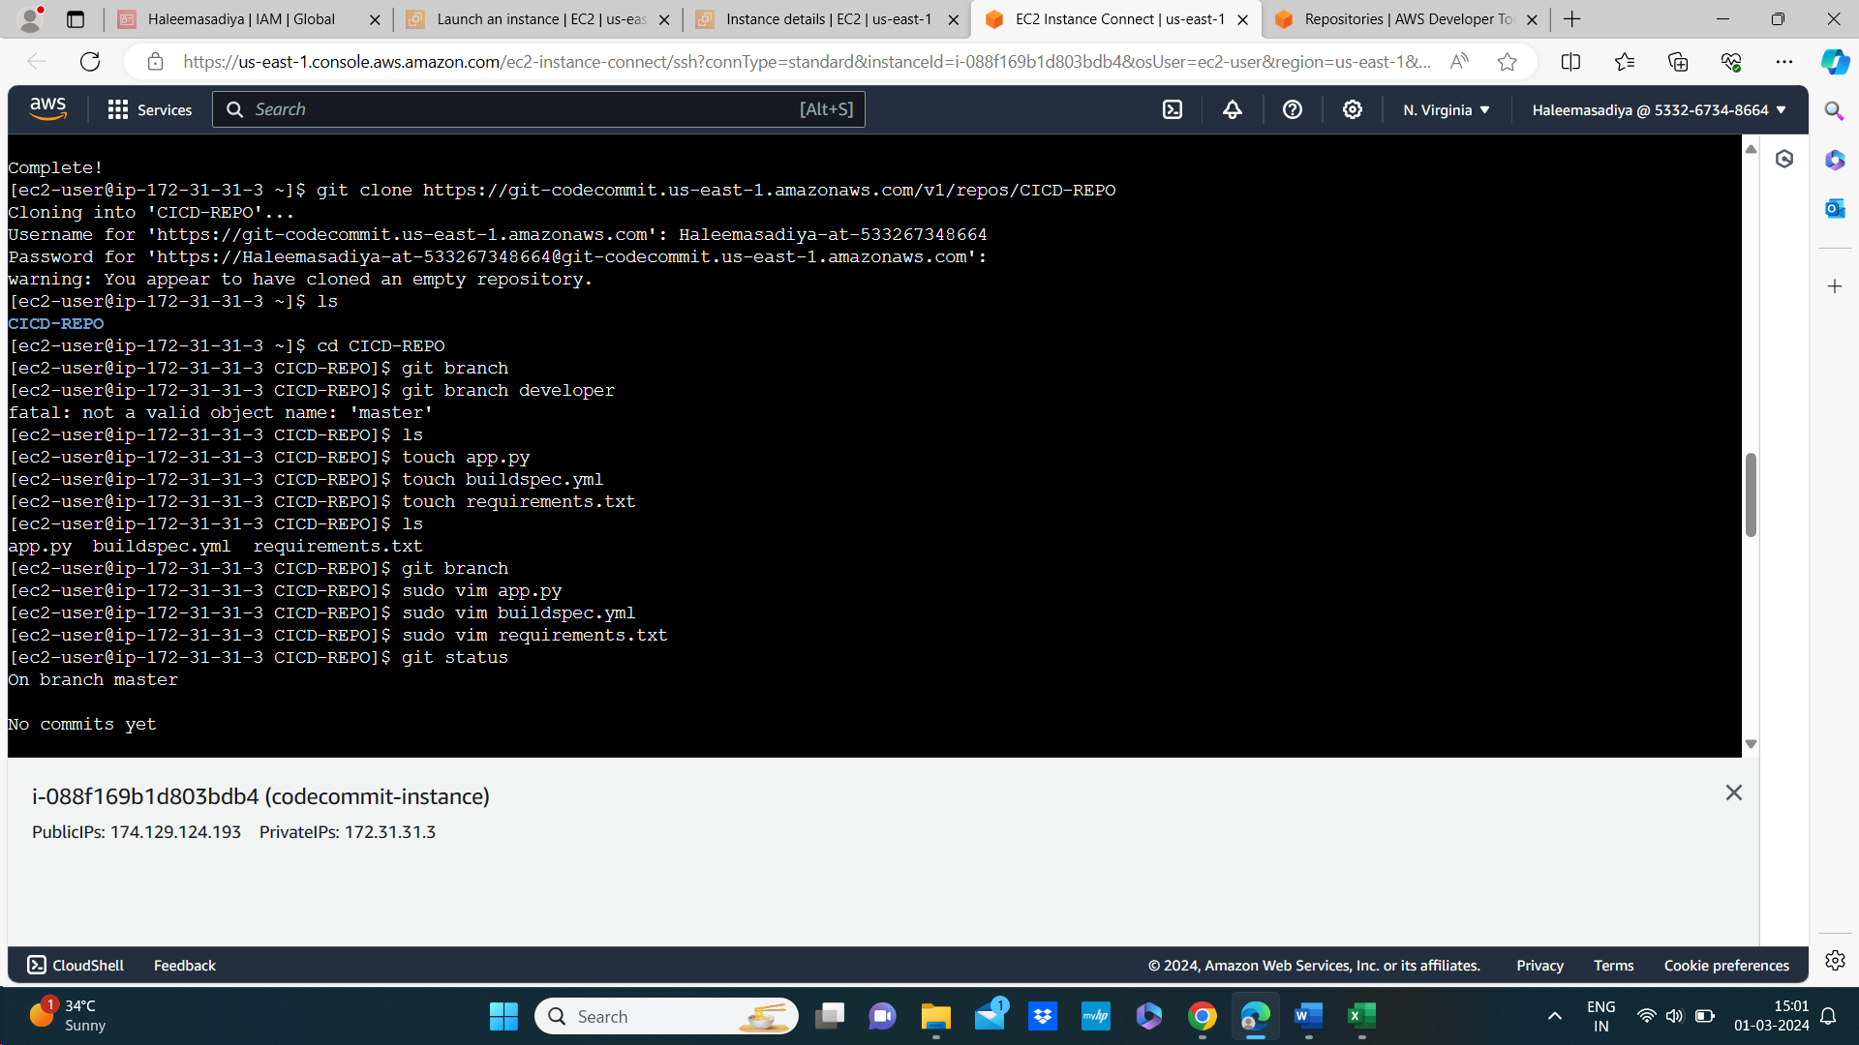

Now refresh the codecommit all the files we created are present there

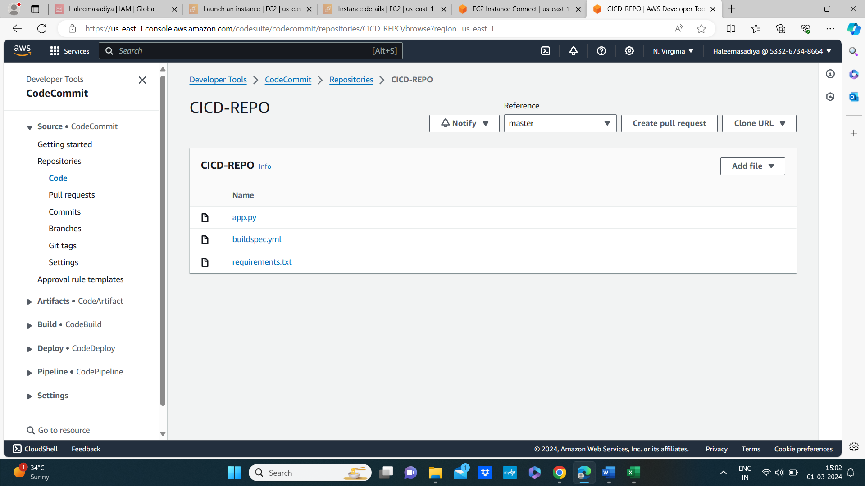

Create elastic beans talk environment and check the environment is created or not

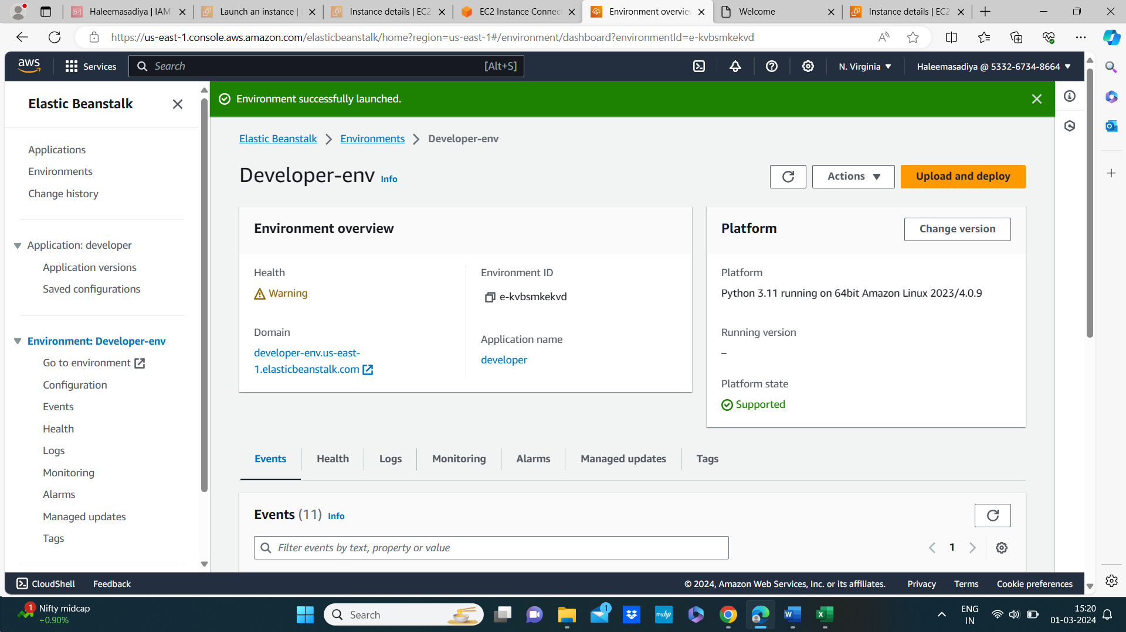



Then create pipline

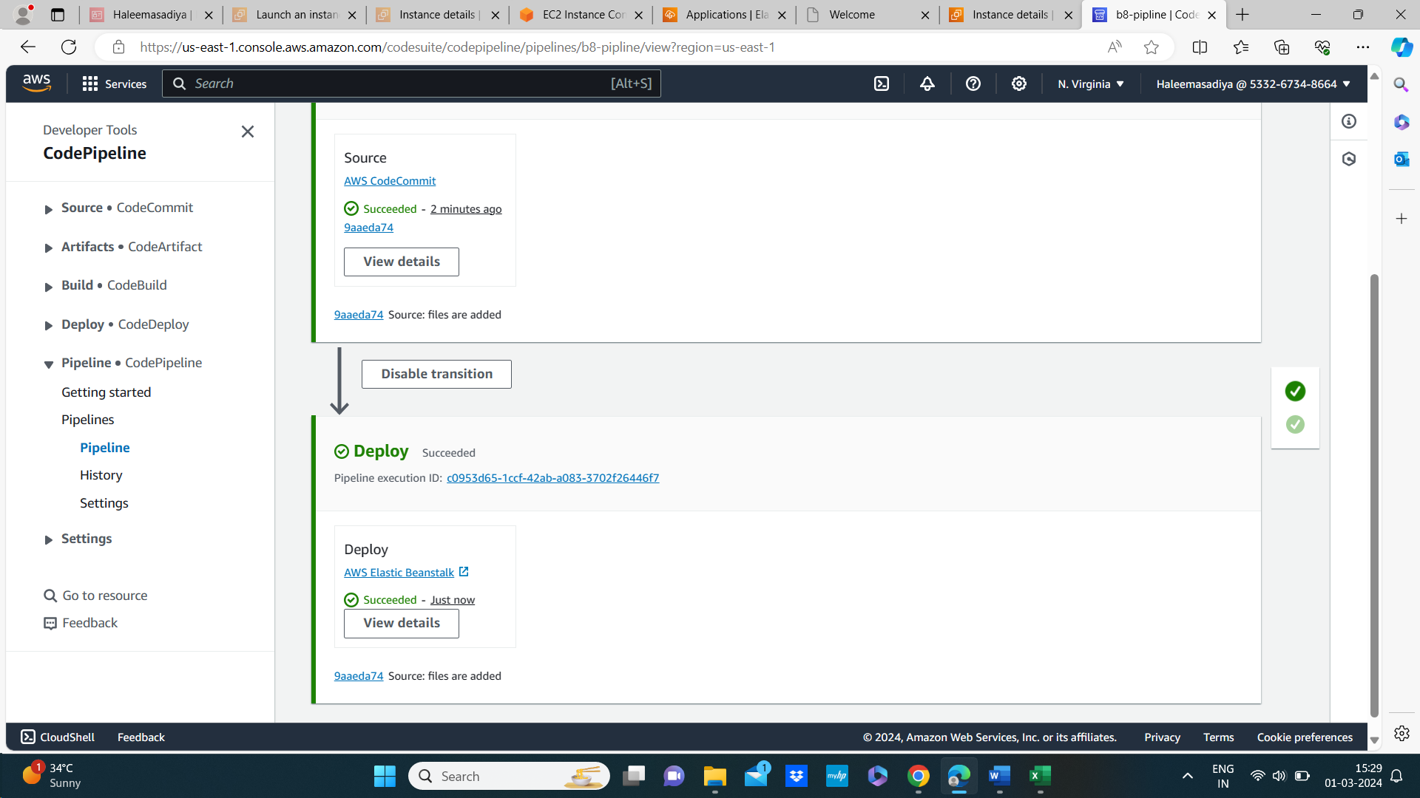

And deployed successful In elastic beanstalk environment

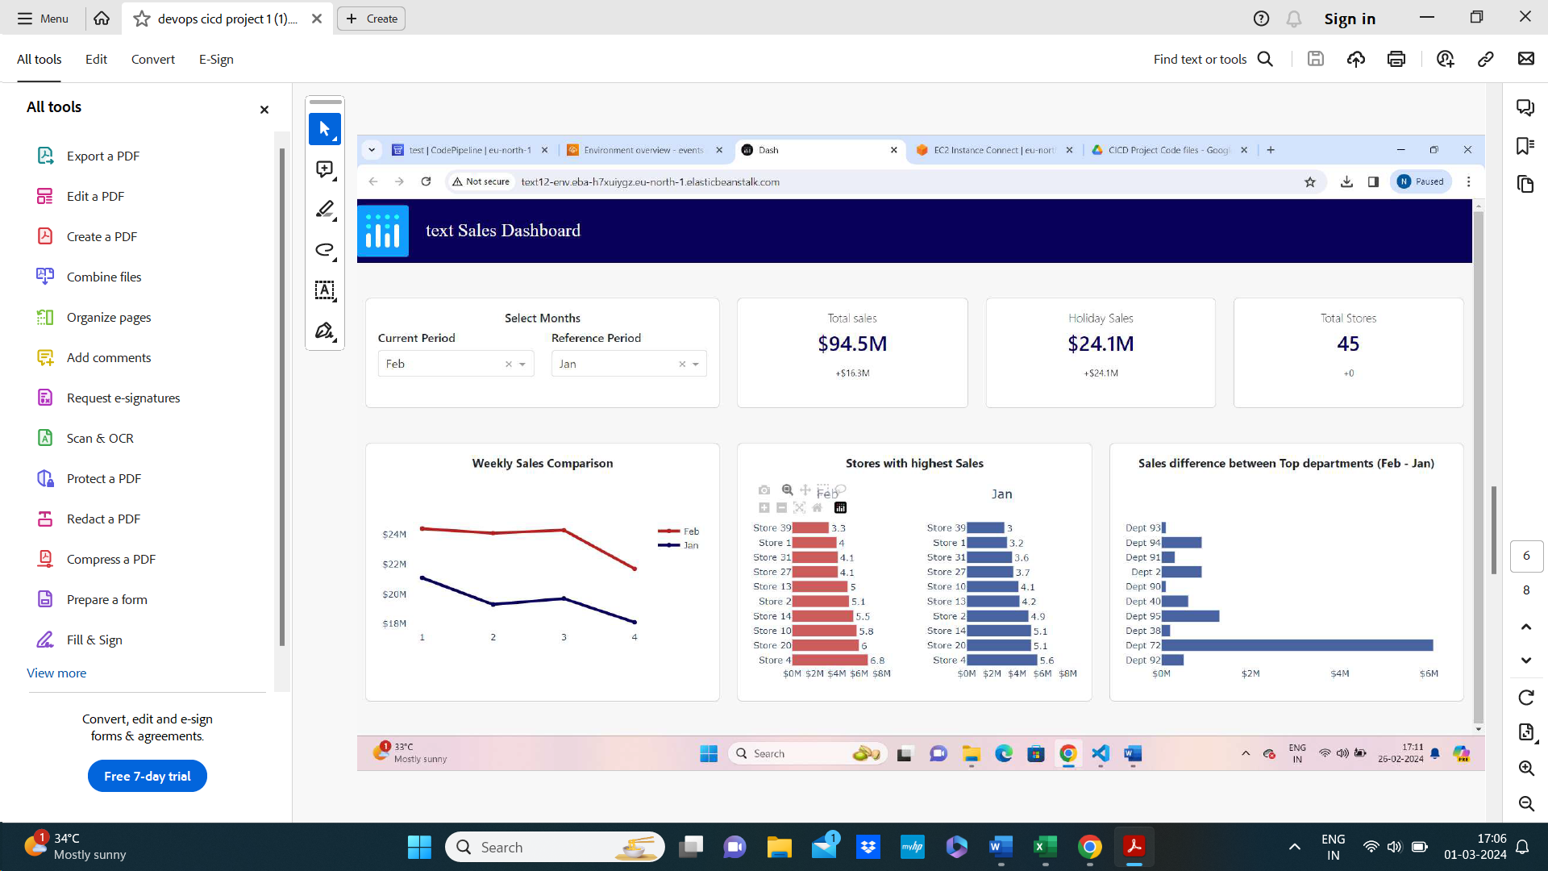

After testing and fixing the bugs

